**Case Study ID: 2320030114**

1. **Title**

**ISP in a rural area must decide between fiber optics and coaxial cable for last-mile connectivity.**

1. **2. Introduction**

* Overview

The last-mile connectivity refers to the final leg of the telecommunications network that delivers internet services to end-users. In rural areas, the sparse population and challenging terrains pose unique challenges for ISPs. Fiber optics offers unparalleled bandwidth, speed, and scalability but requires substantial initial investment and expertise. On the other hand, coaxial cable provides a more affordable solution but is limited by lower bandwidth capacity and higher maintenance needs. The decision must balance current demands, future growth, and financial feasibility.

* Objective

The objective of this analysis is to provide a comprehensive evaluation of fiber optics and coaxial cable technologies for last-mile connectivity in rural areas. Specifically, the goals are to:

1. Assess the technical capabilities and limitations of each technology.
2. Compare the cost implications of installation, operation, and maintenance.
3. Examine the scalability and future-proofing potential for long-term use.
4. Identify key factors influencing decision-making, including population density, geography, and existing infrastructure.
5. Recommend the most suitable technology for delivering reliable and affordable internet services to rural communities.

. **3. Background**

* Organization/System /Description

The Internet Service Provider (ISP) is tasked with delivering high-speed internet connectivity to underserved rural areas. As a key player in bridging the digital divide, the ISP must evaluate infrastructure solutions that balance affordability, scalability, and reliability. The organization’s primary goal is to provide sustainable and efficient internet services to improve access to education, healthcare, commerce, and communication for rural communities..

* Current Network Setup

The core or backbone network is established and operational, typically connected to regional data centers or major urban hubs. It consists of fiber-optic cables or microwave links capable of transmitting high-speed data to the edge of rural regions.

**Current State**:  
The last-mile network, which bridges the gap between the core network and individual homes, businesses, or institutions, is limited or outdated.

* **Coaxial Cable**: In some areas, coaxial cable networks exist but are decades old and support limited bandwidth, often insufficient for high-speed internet demands.
* **DSL (Digital Subscriber Line)**: Copper-based DSL technology is commonly used, but speeds are slow (often below 10 Mbps) and degrade significantly with distance from the central office.

**4. Problem Statement**

The lack of reliable and high-speed last-mile connectivity in rural areas is a significant barrier to digital inclusion and economic development. Despite the presence of a core network, outdated or insufficient last-mile infrastructure, such as aging coaxial cables, DSL lines, or wireless solutions, fails to meet the growing demand for bandwidth-intensive applications like video conferencing, online education, telemedicine, and e-commerce.primary objective is to develop a robust, secure, and scalable network that enables IoT devices to exchange data reliably while addressing urban challenges like traffic congestion, resource optimization, and public safety.

* Challenges Faced

Challenges faced like, Connectivity issues, Data overload, Scalability Concerns, Energy consumption, Security Risks, Real-time Data Processing .Additionally, energy consumption remains a concern for battery-powered devices that require continuous operation. Security risks, such as cyberattacks and data breaches, threaten the reliability of IoT networks. Moreover, the high costs of deploying and maintaining the infrastructure make it challenging for widespread adoption. Finally, ensuring low-latency data processing for critical applications like traffic management and emergency response adds another layer of complexity. Addressing these challenges requires a combination of advanced technologies, robust designs, and cost-effective strategies.

**5. Proposed Solutions**

Fiber-optic would be the preferred solution for last-mile connectivity in a rural area due to its higher bandwidth, faster speeds, and future-proofing capabilities compared to coaxial cable. Although the initial installation cost might be higher, fiber-optic offers better long-term performance and scalability, making it a more reliable and efficient choice for meeting growing data demands.

1. **Implementation**

Implementation :

Implementing fiber-optic infrastructure in a rural area would involve several key steps. First, the ISP would need to conduct a feasibility study to assess the area's topography, existing infrastructure, and potential challenges like remote locations or low population density. Then, a strategic plan for routing the fiber-optic cables must be developed, which could include burying cables underground or using aerial methods along utility poles. Partnering with local municipalities for permits and access to rights-of-way would be essential. After installation, the network would need to be tested for performance and reliability.:

**Network Management Software:**

Monitor network performance (speed, uptime, etc.)

Detect and resolve outages in real-time

Manage traffic flow efficiently

**Customer Portal/App:**

Enable service requests, billing, and technical support

Allow customers to view service status and usage data

Provide account management features

**Device Integration**:

Device integration for fiber-optic connectivity involves ensuring seamless communication between the network infrastructure and various customer devices. This includes the integration of modems, routers, and other networking equipment that connect end-users to the fiber-optic network. ISPs would need to provide compatible devices that support the high speeds and capabilities of fiber optics, ensuring they can handle gigabit-level data transmission. Additionally, these devices must be configured to work with the ISP’s network management software for diagnostics, performance monitoring, and troubleshooting.

**Security Deployment**:

• **Encryption:**

* Ensuring end-to-end encryption of data to protect user privacy during transmission across the fiber-optic network.
* Use of secure communication protocols, such as TLS or VPNs, to safeguard data in transit.

.

**Training and Awareness**:

* **Technical Training:** Provide technical teams with in-depth training on fiber-optic installation, maintenance, and troubleshooting. This includes understanding the unique challenges of rural areas and how to address them.
* **Security Awareness:** Train employees on the latest cybersecurity practices, including how to recognize and mitigate threats like phishing, malware, and DDoS attacks. Regular security drills and updates will ensure staff are prepared for evolving threats.
* Timeline :

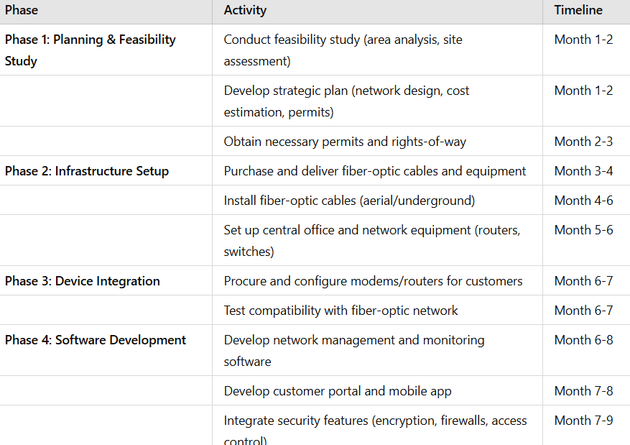

**7. Results and Analysis**

* Outcomes

The analysis of the project’s success would focus on several key metrics. First, the performance of the network—measured by speed, uptime, and capacity—should show a marked improvement over previous systems. Customer satisfaction surveys and feedback would help gauge the perceived value and usability of the service. Additionally, security metrics, including the effectiveness of encryption and intrusion prevention measures, would be analyzed to ensure the network remains protected from external threats. The scalability of the infrastructure would also be assessed, ensuring that future demand can be met without requiring significant reinvestment in the near future. Finally, financial analysis would evaluate the return on investment (ROI), balancing the initial installation costs with long-term revenue from customers and cost savings from improved operational efficiencies.

**8. Security Integration**

Security and integration are critical components when deploying a fiber-optic network, especially in rural areas where the infrastructure might be more vulnerable. Here’s how security and integration would work together in such a project:

**Security:**

**Network Encryption:**

**End-to-End Encryption:** All data transmitted over the fiber-optic network should be encrypted to ensure privacy and prevent interception. This includes using secure protocols such as TLS or VPNs for data in transit.

**Secure Data Storage:** Ensuring that customer data and network logs are stored securely with encryption at rest to prevent unauthorized access.

.**9. Conclusion**

* Summary

In conclusion, the implementation of fiber-optic connectivity in rural areas presents a transformative opportunity to provide high-speed, reliable internet access where traditional broadband services may have been limited or unavailable. By focusing on a robust security strategy and seamless integration of both hardware and software, the ISP can ensure the network is not only fast and scalable but also secure against potential cyber threats. The successful integration of fiber-optic technology will improve the quality of life for rural residents, support local businesses, and foster digital inclusion. With proper planning, training, and ongoing support, the project can lead to long-term sustainability and customer satisfaction, while also enabling future growth as the demand for higher bandwidth continues to increase..

**10. References**

**Citations : Reference Research papers**

**NAME: M.Praneetha**

**ID-NUMBER:2320030114**

**SECTION-NO:1**